# 4.5 Project Reflection

***Task Split by Student***

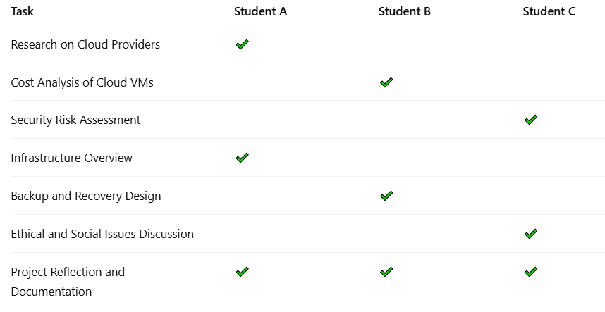

***Comparison of commits v/s Task Performed***

|  |  |  |
| --- | --- | --- |
| Student | Commits | Task performed |
| Student A | 12 | Infrastructure overview completed, cloud provider research completed, and project reflection. |
| Student B | 8 | Cost analysis and backup & recovery design |
| Student C | 10 | Security risk assessment and discussion on ethical and social issues |

NOTE:

Although the number of commits differs between students, this can be explained by the nature of the tasks that they worked on. For instance, tasks such as research and infrastructure design are less likely to have more committees but will require detailed analysis and documentation. On the other hand, other activities, such as cost analysis and backup design, tend to be more often subject to changes in the repository, which implies a larger count of the commits. The total contributions of every student are relative to the complexity and size of the given task.

***Commit Activity over Weeks***

Over the term, one could find that all students made commits for 7 out of 10 weeks. The commitment frequency was roughly even, though there were spikes in weeks that were heavy in solutions development (e.g., finalizing the infrastructure overview or cost analysis. We believe that the rate of commits was good enough, with tasks being ready for review and group discussions on time. Sometimes, there were delays resulting from varied availability and conflict in duties.

***Group Dynamics, Issue, and Future Improvements***

As far as communication is concerned, our group was effective. We arranged face-to-face meetings as well as meetings after class, though most of the discussions happened online through email and such collaborative tools as Slack and Google Drive. We also held weekly meetings for updates; in such a way all the team members were kept informed on the progress.

A challenge that we had was scheduling group meetings. To enhance future tasks, we would like to incorporate the use of such facilitative tools as Trello or Asana to monitor tasks and deadlines. This would assist us in spreading the workload more evenly, and no one will be overwhelmed. Another problem that remained was the time lag in feedback for some sections. In future projects, we will allocate particular times for peer review so that working relationships will be less troublesome.

Future Technique Suggestions:

* Using Task Management Tools: Makes it possible to track responsibilities, deadlines, and task progress.
* Regular Check-Ins: Scheduling regular check-ins, especially with the new members, avoids misunderstandings and early identification of issues.
* Peer Reviews: Routine review of each other’s assignments keeps quality and boosts teamwork.

# Conclusion

Finally, this project has achieved to investigate the feasibility of migrating the IT infrastructure of a travel agency to the cloud with the thorough consideration of cloud providers, cost, security, and backup options. By analyzing choices from AWS and Azure, we concluded that cloud-based solutions have numerous benefits in comparison to on-premise systems, like having better scalability and cost-efficiency, and more effective disaster recovery. The listed security measures, like firewalls, encryption, etc., provide strong protection of sensitive data. The project also showed the significance of the data privacy laws, such as the Privacy Act 1988 and GDPR. All in all, moving to the cloud has long-term advantages, including ensuring that the operations are efficient, secure, and compliant, thus, a shared contribution from the team created a proper and complete result.